PROGRAM OVERVIEW: Sociology majors

Our students connect intellectually and personally with sociology coursework. They think critically about their classroom experiences, consider the larger social world, and identify the moral and ethical implications of sociological knowledge. In sum, they cultivate sociological imaginations—the ability to make connections between personal experiences, social structures, culture, and history.
Sociology examines the complexity of social life through an exploration of topics that range from enduring forms of inequality to interactions between individuals. How is the world socially organized? What is society’s impact on individuals? How do culture and power shape the way we define social issues? How do societies differ around the world? How are inequalities based on race, class, gender, sexuality, disability, and age constructed and maintained? Sociology explores the formation of personal identities, social institutions, collective movements for social change, as well as how such micro and macro forces interact.
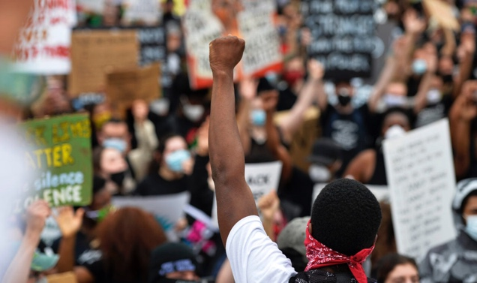
At Drake, sociology students thoughtfully engage with critical social issues. The program combines social theory and research design coursework with elective classes chosen by the student based on personal interests. Community-engaged learning provides hands-on experience with local, national, and global contexts. The major prepares students for graduate school and professional work in nonprofit sectors, government service, social services, law, human resources, higher education, and other fields.

SOCIOLOGY OFFERS THREE OPTIONS FOR MAJORS

Sociology Major (36 credits)
Sociology Major with a Track in Crime, Violence, and Justice (42 credits)
Sociology Major with a Track in Social Services, Policy, and Advocacy (42 credits)

DEGREE REQUIREMENTS
Sociology Major (all dept courses are 3 credits)

Core Requirements (15 credits)
SOC 01: Introduction to Sociology
SOC 42: Sociological Inquiry
SOC 65: Social Science Data Literacy
SOC 175: Theories of Inequality
SOC 199: Sociology Capstone

One additional methods course from the following list: (3 credits)
SOC 159: Methods of Social Research
ANTH 156: Ethnographic Methods
SOC 77: The Art of the Interview
ANTH 78: Practice of Oral History

Sociology Electives (12 credits)
•At least 6 credits need to be above 100 level. Up to 6 credits can be Anthropology courses.

SOC 90: Effective Listening  SOC 78: Sociology of Childhood  SOC 80: Social Problems  SOC 81: Medical Sociology  SOC 85: Sociology of Everyday Life  SOC 105: Race, Gender and Poverty  SOC 122: Making Families Public  SOC 137: Women, Madness, and Culture  SOC 50: Sociology of Family  SOC 162: Women and Work  SOC 154: Poverty and Society  SOC 171: Grief and Loss  SOC 181: Death and Society  SOC 146: Restorative Justice  SOC 140: Youth and Crime | SCS 179: Mass Incarceration  SOC 170: Deviance  SOC 177: Gender and Violence  SOC 161: Race and Ethnicity  SOC 60: Intro to Crime and Justice Studies  ANTH 24: Anthropology of Religion  ANTH 156: Representing Race  ANTH 175: Medical Anthropology  ANTH 180: Ritual and Myth  ANTH 125: Traveling Cultures  ANTH 145: Global Reproductive Politics  ANTH 170: Global Political Violence

Interdisciplinary Electives (6 credits)
Two courses from other disciplines. See approved list below.

EDUC 162: Urban Education and Immigration  EDUC 183: Social Context of Urban Schools  EDUC 186: Youth, Culture, and Society  EDUC 164: Perspectives on Race, Ethnicity, and Gender  LPS 135: Justice Reform  LPS 113: Law and Social Change  SCSR 60: Media Culture and Communication  SCSR 114: Rhetorics of Race  POLS 117: Race and American Politics  POLS 127: Global Health  POLS 136: Racial Justice & Human Rights in the U.S. Since WW II  POLS 157: Crime and Punishment in United States | POLS 175: Human Trafficking  PSY 135: Psychology of Prejudice  PSY 044: Adult Development and Aging  PHIL 136: Theories of Justice  REL 117: Religious Models of Restorative Justice  WLC 148: Intercultural Communication  ENSS 107: Civic Environmentalism and Smart Growth  ENSS 135: Global Change: The Science and Policy of Global Warming  ENSS 157: Environmental Justice  HIST 185: Public Health and Medical History  HIST 188: Urban Environmental History  REL 119: Death & Dying
TOTAL credits: 36

